**Screens**

1. Splash screen
2. Welcome screen with Sign in and sign-up buttons
3. Sign-up screen
   1. Profile picture (Use Camera or Gallery ) ( Ask permission to use camera and gallery)
   2. First Name
   3. Last Name
   4. Email Address
   5. Password
   6. Confirm password
   7. Mobile Number
   8. Address
      1. House/flat Number
      2. Street
      3. Town/City
      4. Postal Code ( e.g. : TS1 3BX)
4. Ask permission to use location Screen
5. Login screen (Validations needed) (Integrate face id and fingerprint)
   1. Email / Mobile number
   2. Password
   3. Forgot password
6. Forget password screen (Validations needed)
   1. Email / Mobile number
7. Enter OTP screen (Validations needed)
   1. Enter the otp received to email or mobile number
8. New password confirmation screen (Validations needed)
   1. New password
   2. Confirm new password
9. 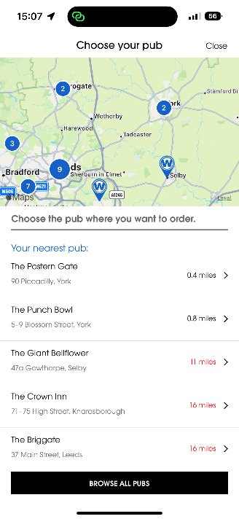Landing Page

Exactly same as this. It must display your current location and nearest OneSeconds around you with the distance ( Distance should be in miles same as in reference.

After clicking close button, it should direct to Home Page.

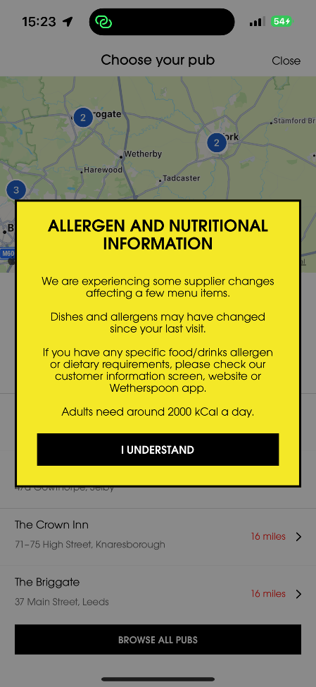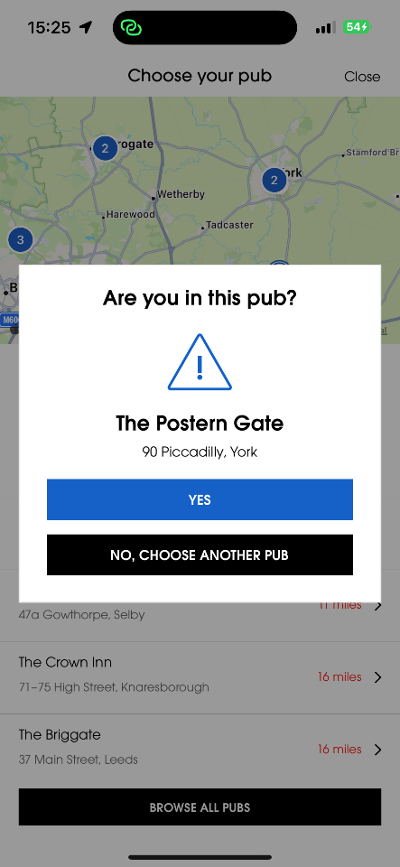After selecting the nearest OneSecond the following popup must be appeared.

1. Home Page

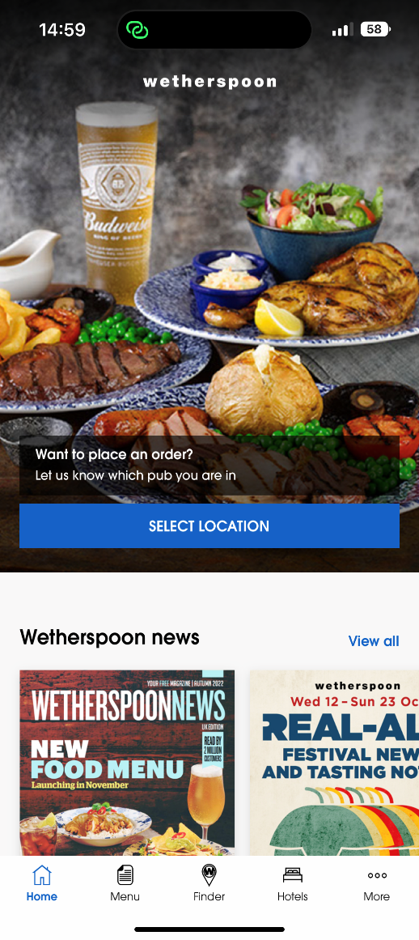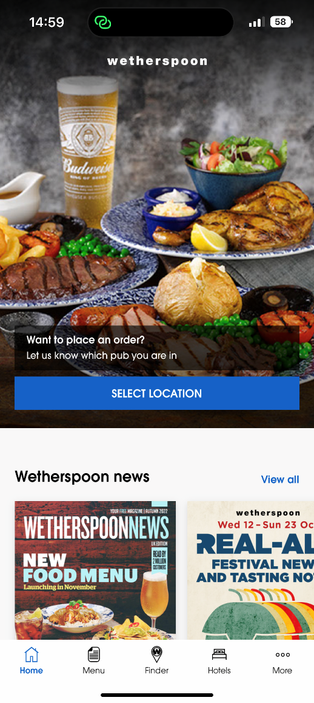

Same as this. In bottom layout Home / Menu / Cart / My orders/ User. Only these 5 icons enough.

1. Menu
   1. Menu will direct to landing page and after selecting the restaurant and table menu will display. Same as wheatherSpoon
2. Table Selection screen
   1. It should scan the QR code on the table and table number should retrieve from that QR code
3. Cart screen
   1. It should display all items we have selected with the total bill. Should be able to add or remove items from the cart before placing the order.
   2. When placing the order payment method selection should be there.
      1. Google pay
      2. Credit/Debit card
   3. No need to integrate payment gateway. Just put the order button to place the order
   4. Should be able place more than one order.
   5. After placing the order, it will direct to My orders.
4. My Orders screen
   1. It will display all on going orders with the progress. It should be with the progress bar with remaining time. (We can put 15 min time duration)
   2. And order ready pop up should appear after the completion of 15 mins
   3. After completion of order, we can use order history screen to see that order.
5. User Screen
   1. User profile pic with name
   2. Order history
   3. My feedbacks (Future works)
   4. Contact us
   5. FAQs
   6. Logout button

Android Studio 3.5.x with Android SDK API level 29, although we will target our apps at Android version 5.0 (API level 21) to increase app compatibility with existing devices.